The UniServe Induction Tube

ASELL – Physics Inquiry Series

Another ASELL Collaborative Initiative

Enchanting the Imagination – Bridging the Gap between ‘Theory’ and ‘Practice’

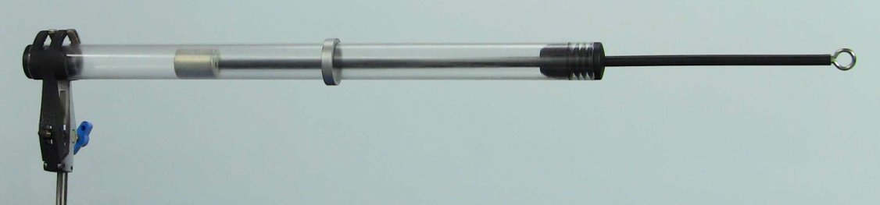 | 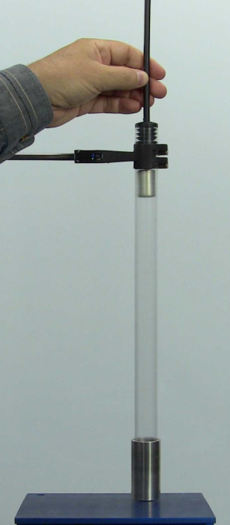
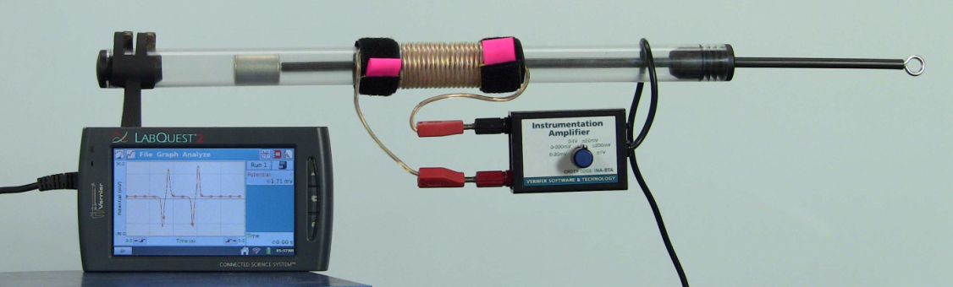

You can also visit the following URL for links to
videos, updated information and related resources.

http://science.uniserve.edu.au/POD/PHYS/70115_D_UniServe_Induction_Tube_Booklet_MAN/70115_AW_UniServe_Induction_Tube_Booklet_MAN.htm

With the UniServe Induction Tube explore the physics that links
‘Theme Park Thrills’ to an ‘Emergency Flashlight’!

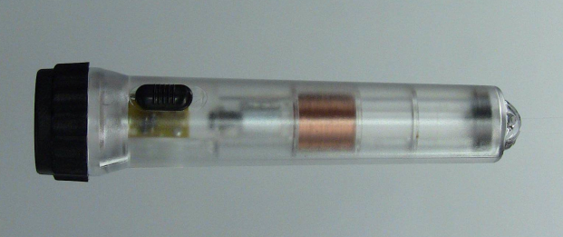

"Tell me and I forget, show me and I remember,
involve me and I understand"
– Chinese Proverb –

The essence of inquiry-based learning is expressed in the third part of the proverb where students and teachers work together to model, explore, observe, ask questions, discuss observations, collect and analyse data, seek answers and draw conclusions about everyday experiences.

Another UniServe Science
Collaborative Initiative

Title The UniServe Induction Tube

Subtitle Inquiry Launch Pad Booklet

Series ASELL - Physics Inquiry Series

Authors

Peter Fletcher University of New England, Armidale, NSW, Australia
Allan Morrison Scientrific Pty Ltd, Yamba, NSW, Australia

Jayme Reid Wauchope High School, Wauchope NSW, Australia
Daniel Fittler O'Connor Catholic College, Armidale, NSW, Australia
Joanne Bourke Hastings Secondary College, Port Macquarie, NSW, Australia
Mitchell Parkes University of New England, Armidale, NSW, Australia
Stephen Bosi University of New England, Armidale, NSW, Australia
Nadya Rizk University of New England, Armidale, NSW, Australia
Jennifer Charteris University of New England, Armidale, NSW, Australia
Vicente Reyes University of New England, Armidale, NSW, Australia
N. Sanjay Rebello Kansas State University, Manhattan, KS, USA
Carina Rebello Kansas State University, Manhattan, KS, USA
Manjula Sharma University of Sydney, Sydney, NSW, Australia

Editor

Peter Fletcher University of New England, Armidale, NSW, Australia

Engineering Design Team

John Cadogan Scientrific Pty Ltd, Yamba, NSW, Australia
Peter Fletcher University of New England, Armidale, NSW, Australia

Downloadable copies and additional support resources available at UniServe Physics

Click On or Cut & Paste the URL below

http://science.uniserve.edu.au/POD/PHYS/70115_D_UniServe_Induction_Tube_Booklet_MAN/70115_AW_UniServe_Induction_Tube_Booklet_MAN.htm

ISBN : 978-0-9924705-0-0

First Published 2015

Published by:
Peter Fletcher and
UniServe Science
The University of Sydney NSW 2006 Australia
http://science.uniserve.edu.au/

Welcome to
The UniServe Induction Tube : Inquiry Launch Pad Booklet

Firstly, I would like to personally thank all the teachers and students who have evaluated UniServe Induction Tube prototypes and provided advice, ideas and suggestions that have culminated in making this project such a great success.

The UniServe Induction Tube has been designed and developed as a multi-purpose flexible resource in collaboration with teachers and students to facilitate investigations into Lenz’s Law, Induction, Eddy Currents, Magnetic Braking, Forces in Magnetic Interactions, Back EMF and lots more!

The purpose of this booklet is to provide students, teachers and other inquiring minds with a suite of seed investigations that utilise the UniServe Induction Tube. These investigations are designed to inspire your creativity and imagination to plan, investigate, observe, collect data, analyse and draw your own conclusions concerning the enchanting interplay between motion, forces, electricity and magnetism.

Inquiry Based Learning comes in many flavours and can mean different things to different people. Here are some tips-n-tricks to keep your inquiry based learning on track.

Remember that inquiry learning has a definite focus and should not be viewed as ‘learners simply doing what they want to do’. Effective and successful inquiry learning requires planning, analysis and reflection. Two central focuses when planning inquiry investigations is the role of information-processing skills (from observations through to synthesis) and the appropriate application of scientific discipline based protocols. We therefore encourage you to carry out formal research as a part of your planning and to also utilise a mix of traditional laboratory instruments and data logging equipment to support your investigations.

A Facilitation Plan promotes creativity and responsibility and provides the general direction that will allow both individual learners and the whole class to achieve the set goals, without a lock-step approach for every individual. Our team therefore recommends that teachers should consider developing a Facilitation Plan in consultation with their students for inquiry learning activities rather than a ‘traditional’ lesson plan.

If you use the UniServe Induction Tube as a classroom or lecture demonstration we recommend you use the Predict-Observe-Explain (or similar) facilitation strategy to maximise audience engagement.

We trust you will enjoy the UniServe Induction Tube and we encourage you to share your investigations and provide feedback and ideas for ongoing improvements and resource development.

Please do not hesitate to contact us at uniserve@physics.usyd.edu.au You can also visit the following URL for links to videos, updated information and related resources.

http://science.uniserve.edu.au/POD/PHYS/70115_D_UniServe_Induction_Tube_Booklet_MAN/70115_AW_UniServe_Induction_Tube_Booklet_MAN.htm

Regards

Peter Fletcher
On behalf of the ASELL - Physics Team
Equipment List

Basic Induction Tube Kit
- Induction Tube (Acrylic Tube with cylindrical super-magnet, axially magnetised N/S)
- Control Rod (Plastic rod with an embedded ferromagnetic slug and eyelet to control magnet position and motion)
- Aluminium Tube (Approximately 60mm Long)
- Aluminium Ring (continuous)
- Aluminium Ring (with slit)
- ‘Silvered’ Plastic Ring (that looks like a continuous aluminium ring)
- Long Single Wire (with 2 banana plugs)

Coil Accessories
- Long Twin Wire (with 4 banana plugs)
- 2 x Velcro Wire Coil Retainers
- IEC ‘Hodson’ 600 turn coil (with banana sockets) (Recommended)
- IEC ‘Hodson’ 300 and 1200 turn coils (with banana sockets)
- IEC Bobbin (to wind own coils)

Shaky Torch
- Emergency Shaky Torch

LED and Bulb Accessories
- Small Neon Bulb (90Volt with banana plug sockets)
- Bi-Coloured LED Red/Green (with banana plugs)
- Single red LED (with banana plugs)
- Two red LEDs (opposite polarity with banana plugs)
- White LED (with banana plugs)

AC Rectifier and Electrical Storage (to make your own Shaky Torch circuit)
- Rectifier Bridge or 4 suitable diodes to build a Bridge (full-wave rectifier)
- Diode (to make a half-wave rectifier)
- Capacitor (low voltage super capacitor or low voltage high capacity electrolytic capacitor)
- Switch on/off/on - Pushbutton switch

Lab Equipment
- Compass (oil damped)
- Jumper Wire (banana plugs)
- Alligator Clip (to convert banana plug to alligator clip – to connect to rectifier bridge etc)
- Morse Tapper Key (momentary switch)
- Analogue Voltmeter (Centre) +/- 5V
- Micro Ammeter (Centre) +/- 50uA
- Oscilloscope
- Data Logger with sensors (Instrumentation Amplifier) (Current Probe) (Voltage Probe) (Rotational Motion Sensor) (Force Sensor)
- Variable Resistor or Rheostat

Equipment Suppliers
- UniServe Induction Tube Kits are available at http://www.scientrific.com.au/product.php?p=9481
- Recommended IEC accessories are available from Scientrific Pty Ltd and most Australian Educational Equipment Suppliers (Please Note: Ensure they are genuine IEC components as sizing is important)
Index

FOUNDATION INVESTIGATIONS
(Using Basic UniServe Induction Tube Kit Supplied Equipment)
4
- Three Little Rings
- Amusement Park Thrills
- Who Dropped the Magnet? A Symmetrical Tale!
- Coil vs Tube - Part 1

EXTENDED INQUIRIES
(Requiring additional accessories and laboratory equipment as listed)
10
- Coil vs Tube - Part 2 (with even more “Coil-ee” questions!)
- Shaky Torch Unveiled
- Back EMF can be Quite Strange?
- Electromagnetic Cannon (well at least make a magnet jump)

QUANTITATIVE ANALYSIS
(Requiring additional accessories, laboratory equipment and data logging as listed)
16
- The Long and Short of Coils
- Troublesome Twins
- The Force and EMF vs Displacement Investigations
  - EMF vs Displacement - for various coil configurations
  - Force vs Displacement - for moving a magnet through an Aluminium Tube
  - Force vs Displacement - for moving magnet through an ‘energised’ coil.

HUMAN ENDEAVOUR AND APPLICATION
23
- Historical Context
- Historical Entities
- Technological Applications

THE PHYSICS
24
- Symmetry
- Magnetism
- Law’s
  - Lenz’s Law
  - Faraday’s Law of Induction
- Terminology

INTERESTED IN GETTING INVOLVED!
INTERESTED IN DEVELOPING AND SHARING IDEAS AND RESOURCES
24

FOUNDATION INVESTIGATIONS
(Using Basic UniServe Induction Tube Kit Supplied Equipment)

Three Little Rings

A Physics Sequel to a Folktale

Once upon a time there were Three Little Rings. Only one of them enjoyed this exploration, the other two couldn’t work out what all the excitement was about…

Seed Exploration

You will need:
UniServe Induction Tube
Control Rod
Aluminium Ring (continuous)
Aluminium Ring (split)
Silvered Plastic Ring

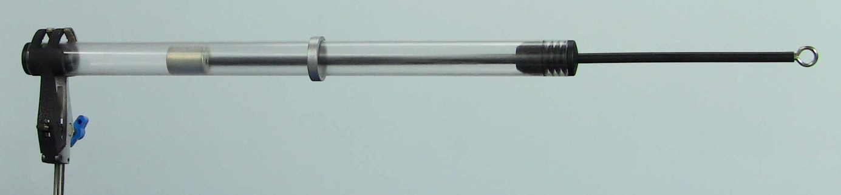

Steps
Step 1: Insert the Control Rod into the UniServe Induction Tube
Step 2: Hold the UniServe Induction Tube horizontally and slide one of the Rings to the centre of the tube.
You might like to get your friends to make a prediction about what they think will happen when you move the magnet past the Ring!
Step 3: Gently use the Control Rod to slide the magnet up and down the tube past the Ring.
Step 4: Then see what happens when you move the magnet a bit faster.
Remember to record your findings!
Step 5: Try the other two Rings and repeat Steps 2-4.

Further Explorations

Idea 1: Hold the Ring as you move the magnet past it. Remember to predict what you think will happen before you try! Compare your prediction to your observation.
Idea 2: Substitute the Ring for the longer Aluminium Tube. Carefully investigate interactions between the moving magnet and the Aluminium Tube.
Idea 3: You could make up your own rings out of different materials and try them out. Try some aluminium or copper foil rings. Try a paper ring!
Idea 4: Plan and carefully investigate how the motion of the magnet (the speed, the starting position, acceleration etc) effects observed interactions.

A good ‘eye for detail’ is needed to observe these interesting interactions.
Remember to record all your experimental findings and discuss them with your friends!

Some Research and Discussion Points

- What differences did you observe between each of the rings?
- For the Ring that enjoyed this exploration, do some research and find out what caused it to ‘behave’ the way it did? Discuss with your friends why the other two Rings didn’t ‘enjoy’ the investigation as much!.
- When you carefully explored the interaction between the Aluminium Tube and the magnet how many interesting things did you discover? Share your findings with others and build a ‘mega-list’ of interesting interactions.
- What were the similarities and differences between the behaviours of the Aluminium Tube and the smaller Aluminium Ring?
Amusement Park Thrills

Have you ever wondered how the brakes work on these giant drop amusement rides? When is a good time to wonder about this?

I wonder how the brakes work?
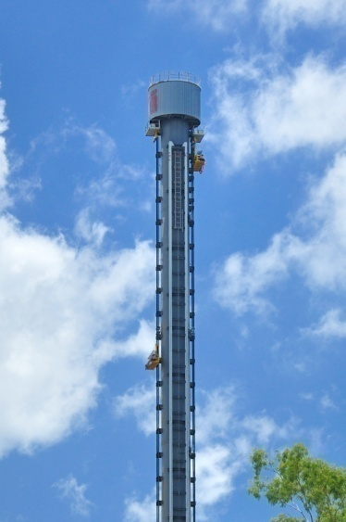

The Giant Drop dominating Australia’s South East Queensland skyline at the northern end of the Gold Coast standing 119 metres high (39 storeys). It opened at Dreamworld in 1998 and has carried more than five million passengers to date. (Images Courtesy Dreamworld)

Seed Exploration
You will need:
UniServe Induction Tube
Aluminium Tube

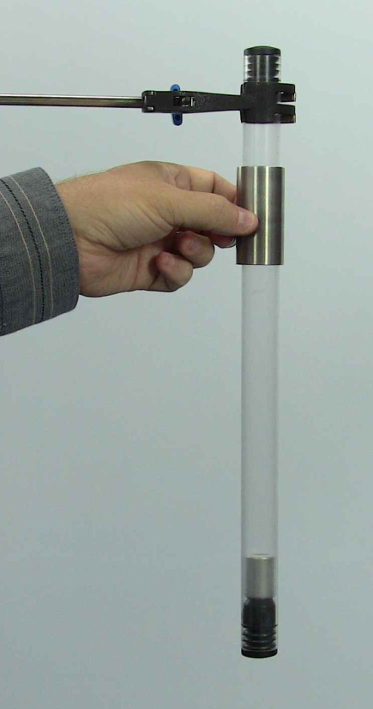 | Steps:  Step 1: Setup the UniServe Induction Tube vertically so the magnet is sitting on the rubber stopper at the bottom of the tube.  Step 2: Slide the Aluminium Tube onto the UniServe Induction Tube and hold the Aluminium Tube at the top ready for the drop.  Predict what might happen!  Get your friends to make a prediction too!  Step 3: Keep hold of the top of the UniServe Induction Tube and release the Aluminium Tube and let it drop!

Further Explorations

Idea 1: Increase the mass of the Aluminium Tube. You could tape (or use ‘blu-tack’) to secure some non-magnetic objects. (Remember to evenly distribute the added mass to reduce frictional effects!)
Idea 2: Substitute the Aluminium Tube and try dropping the Silvered Plastic Ring, the Aluminium Ring (continuous) and the Aluminium Ring (with slit). Remember to make a prediction before you carry out each experiment.
Idea 3: You could try the drops when the magnet is positioned halfway down the tube. Use the Control Rod to explore what happens when the magnet is at different positions.
Idea 4: Make a video of the drops and analyse the motion by playing back the movie in slow-motion or one frame at a time. You could also try using video analysis software!

Some Research and Discussion Points

- Do some research and see if you can find out exactly how magnets are utilised in the braking systems on various amusement park rides.
- Discuss how the braking mechanism works. (Hint: It is not just the ‘simple’ attraction of a magnet to another magnet. There is much enchanting physics to be discovered!)
- Why do amusement park rides use these magnetic braking systems?
- What are the advantages and disadvantages of magnetic braking over other systems?
- What do you think would happen if the power went off at the amusement park and you were halfway down the giant drop? Any cause for concern?

Who Dropped the Magnet? A Symmetrical Tale!

Symmetry! Turning the World Upside Down… … …

Seed Exploration
You will need:
UniServe Induction Tube
Control Rod
Aluminium Tube

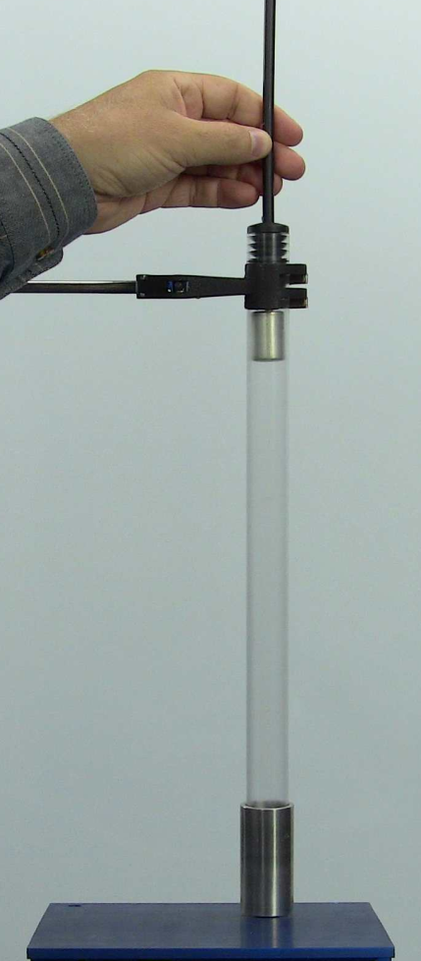 | Steps  Step 1: Setup the UniServe Induction Tube vertically.  Step 2: Slide and position the Aluminium Tube at the base of the tube.  Step 3: Insert the Control Rod into the Induction Tube and lift the magnet up to the top of the tube.  Get your friends to make a prediction of what they think will happen when you pull the Control Rod out of the tube and release the magnet.  Step 4: Pull the Control Rod out of the tube to release the magnet - and down the tube it drops!

Some Research and Discussion Points
- How does this exploration relate to the ‘Amusement Park Thrills’ investigation?
- If you have not already researched ‘Eddy Currents’ this is a good opportunity to do so!

Coil vs Tube - Part 1

Now the great thing about this exploration is that even Physics Professors have to put on their Thinking Caps!

Make sure you have done the ‘Who Dropped the Magnet?’ exploration and ‘think’ you have a good understanding of the physics involved, before you try this one!

If you have done your research you should easily predict what is going to happen! Perhaps? …

Now as you can see we are setting up an experiment to mimic the ‘Who Dropped the Magnet?’ exploration and we are simply replacing the Aluminium Tube with a coil of wire. The ends of coil of wire are connected together to form a circuit, so a current can flow freely in the coil - well that is the plan!

Seed Exploration
You will need:
UniServe Induction Tube
Control Rod
Long Single Wire (with two banana plugs)

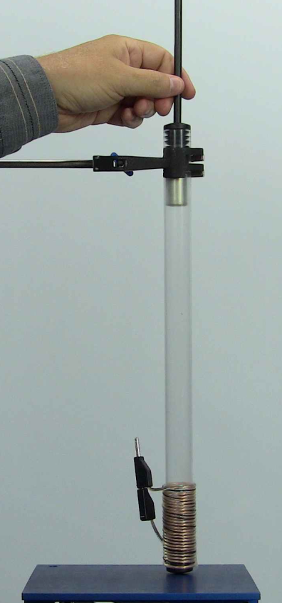 | Steps  Step 1: Using the Long Single Wire neatly wind a 6 cm long coil (approximately 20 turns – the same size as the Aluminium Tube) around the base of the Induction Tube. Use Velcro or some sticky tape to hold the coil windings securely in place. Connect the ends of the wire together (by plugging the two banana plug terminals together) to form a circuit.  Step 2: Setup the UniServe Induction Tube vertically so the magnet is initially sitting on the rubber stopper at the base of the tube.  Step 3: Insert the Control Rod into the Induction Tube and lift the magnet up to the top of the tube.  Get your friends to make a prediction of what they think will happen when you pull the Control Rod out of the tube and release the magnet.  Step 4: Pull the Control Rod out of the tube to release the magnet and down the tube it drops!  Step 5: Discuss your observations and predictions.  Step 6: Then try the ‘Coil vs Tube - Part 2’ investigation.

Further Explorations
Idea 1: Move the coil up the UniServe Induction Tube to a different position.
Idea 2: Wrap more coils.
Idea 2: Wrap the coils in different ways (lots of overlapping coils etc).
EXTENDED INQUIRIES
(Requiring additional accessories and laboratory equipment as listed)

Coil vs Tube - Part 2

… with even more “Coil-ee” questions!

Seed Exploration
You will need:
UniServe Induction Tube
Control Rod
IEC ‘Hodson’ 600 turn coil with banana sockets
Jumper Wire (with banana plugs)

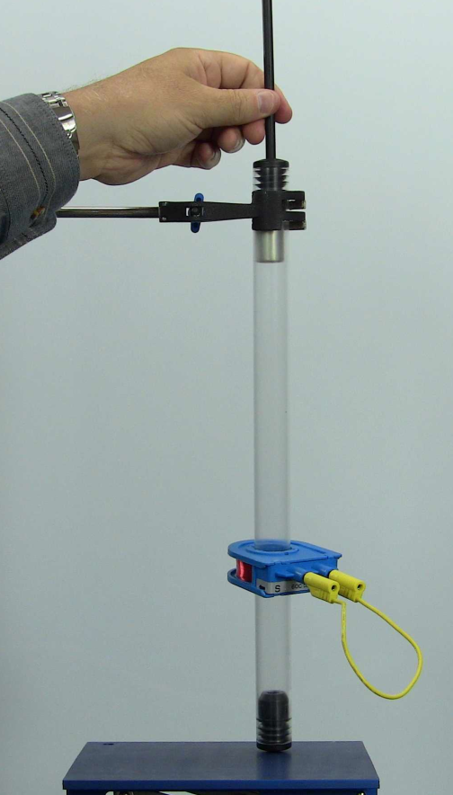 | Steps  Step 1: Use a Jumper Wire to form a circuit by connecting it between the two IEC ‘Hodson’ 600 turn coil banana sockets.  Step 2: Slide the IEC ‘Hodson’ 600 turn coil onto UniServe Induction Tube and secure it 5cm from the base end of the UniServe Induction Tube. You could use a piece of sticky tape (or blu-tac) to secure the coil if you are doing the experiment alone but it is better to have someone hold the coil in this position.  Step 3: Setup the UniServe Induction Tube vertically insert the Control Rod into the UniServe Induction Tube and lift the magnet up to the top of the tube.  Get your friends to make a prediction of what will happen when you pull the Control Rod out of the tube and release the magnet.  Step 4: Pull the Control Rod out of the tube to release the magnet and down the tube it drops!  Step 5: Discuss your observations and predictions.

Further Explorations
Idea 1: Disconnect the Jumper Wire and try the experiment again.
Idea 2: Re-orientate the UniServe Induction Tube in a horizontal position. Now use the Control Rod to move the magnet into and out of the coil. Try this with and without the Jumper Wire connected.
Idea 3: Connect a variable resistor or rheostat into the circuit and plan some investigations.
Some Research and Discussion Points
- How do your observations and predictions compare to the ‘Coil vs Tube - Part 1’ investigation?
- Discuss the relationships between all the previous investigations. What are the common themes?
Shaky Torch Unveiled! – Part 1

Reverse Engineering

The instructions say this is a linear induction flashlight and it is charged by shaking it along its long axis, causing a magnet (visible to the left of the coil of copper wire in the centre) to slide back and forth through a coil of wire to generate electricity.

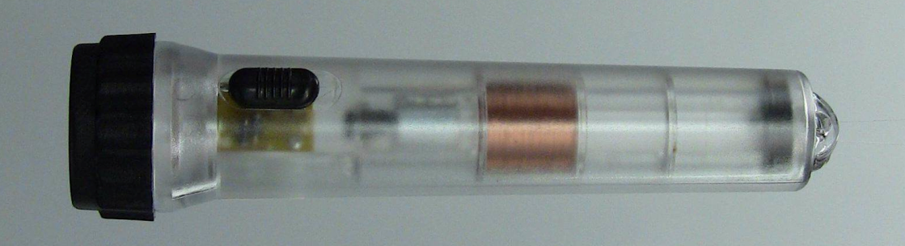

But how does it actually work?

It is often fun to find out how things work by using a process commonly called ‘reverse engineering’. We can see the components used to construct the torch, so no need to pull it apart to find out what is inside!

Following are a set of seed investigations to get you started that examine each of the sub-components making up the torch.

Seed Investigations

You will need:
UniServe Induction Tube
Control Rod
IEC ‘Hodson’ 600 turn coil (with banana sockets)
2 x Jumper Wires (with banana plugs)
Analogue Voltmeter (Centre) +/- 5V
Bi-Coloured LED Red/Green (with banana plugs)
Single red LED (with banana plugs)
Two red LEDs (opposite polarity with banana plugs))
White LED (with banana plugs)

Investigation A - Linear Generator

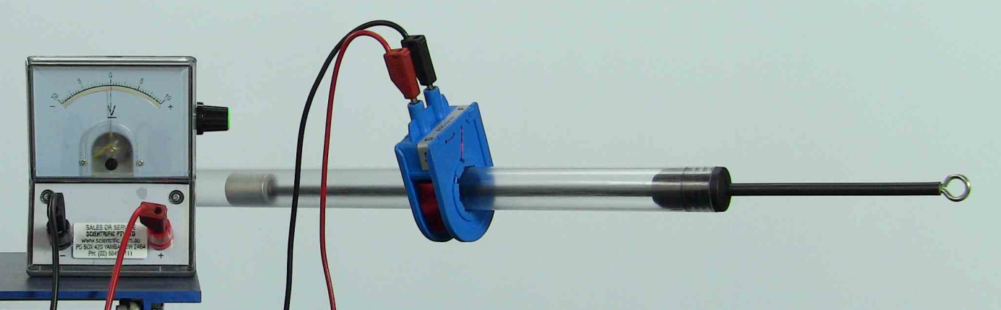

Steps
Step 1: Position IEC ‘Hodson’ 600 turn coil at the centre of the Induction Tube.
Step 2: Connect a zero-centre analogue Volt Meter (+/- 5V) to the IEC ‘Hodson’ 600 turn coil.
Get your friends to make a prediction of what will happen when you use the Control Rod move the magnet through the coil.

Step 3: Test your predictions!
Step 4: Plan some more investigations and try them out!
Step 5: Remember to carefully record the relationships between the direction of motion of the magnet, the speed of the magnet, the position of the magnet relative to the coil and the induced EMF produced.
Some Further Explorations and Discussion Points
- Why did we recommend you use a zero-centred analogue voltmeter?
- What types of electricity can your Linear Generator produce?
- You could try using an Ammeter instead of the Voltmeter. What is the difference?
- What is the relationship between the magnetic polarity and the movement towards, away and through the coil? How would you determine the North and South poles of the magnet in your UniServe Induction Tube?

Investigation B - Lighting the LEDs
Let’s try lighting some LEDs - White LED, Single red LED, Bi-coloured LED and Two red LEDs (opposite polarity).

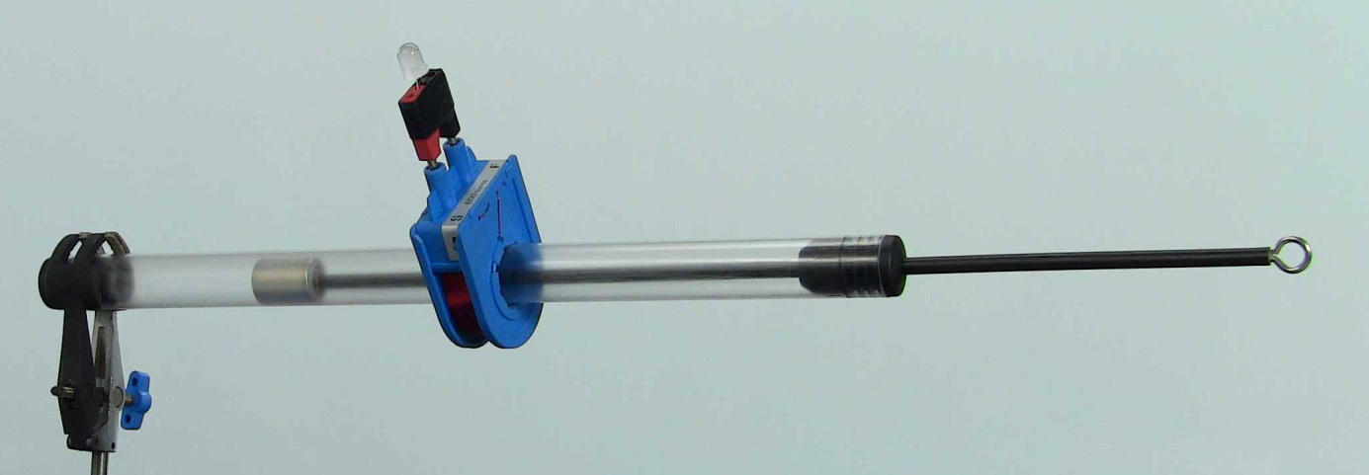

Steps
Step 1: Position IEC ‘Hodson’ 600 turn coil at the centre of the Induction Tube.
Step 2: Plug in one of the LEDs into the IEC ‘Hodson’ 600 turn coil.
Get your friends to make a prediction of what will happen when you use the Control Rod move the magnet through the IEC ‘Hodson’ 600 turn coil.
Step 3: Test your predictions!
Step 4: Remember to carefully record the relationships between the direction of motion of the magnet, the speed of the magnet, the position of the magnet relative to the IEC ‘Hodson’ 600 turn coil, the orientation of the coil and the intensity of the light emitted from the LED.
Some Further Explorations and Discussion Points
- Under what conditions does the LED light up?
- What does the intensity (brightness) of the LED indicate?
- Using the single Red LED. Have you tried investigations with the magnet starting from rest at the centre of the coil? Or stopping the magnet when it reaches the centre rather than passing through?
Shaky Torch Unveiled – Part 2

More Reverse Engineering!

Well we have the basics of our torch.
We just need to turn it from a momentary ‘flash in the dark’ into a real torch we could use!

Seed Investigations

To get started you will need:
UniServe Induction Tube
Control Rod
IEC ‘Hodson’ 600 turn coil with banana sockets
Jumper Wires (with banana plugs)
4 x Alligator Clip (to convert banana plug into an Alligator Clip)
White LED (with banana plugs)
Switch
Rectifier Bridge
Diodes
Capacitor

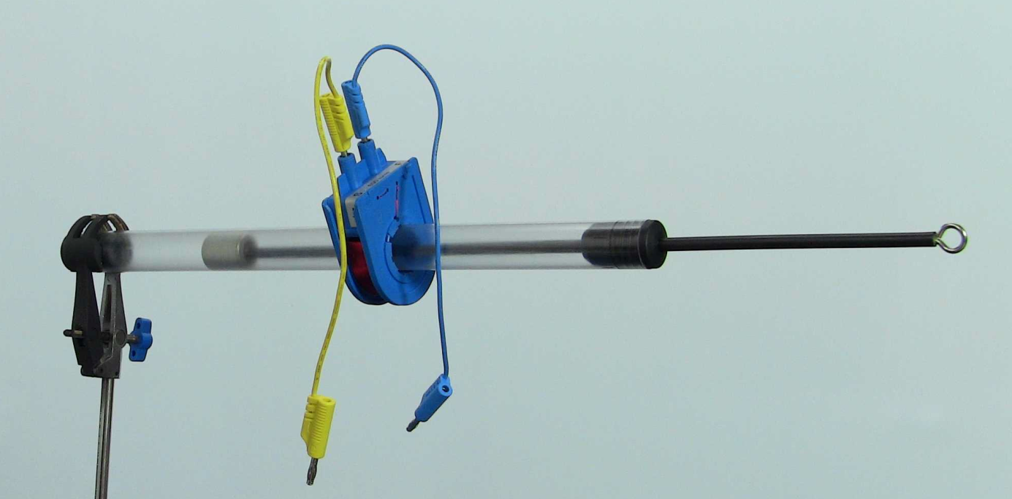

Converting the AC to DC - Investigation C
- Now we will leave it up to you to investigate and design a circuit to turn your AC into DC.
- How many types of circuit designs did you find? What are the pros and cons of each?
- How could you test whether your circuit was successful?

Storing the DC - Investigation D
- Now that you have your DC you can store it!
- What devices could you use? What are the pros and cons of each?
- Plan, design and test your Shaky Torch final design.

Some Further Explorations and Discussion Points
- How could you improve your design?
- Build your own full-wave bridge rectifier out of 4 LEDS.
Back EMF – An Unexpected Manifestation!

Back EMF is usually talked about in relation to electric motors but here is a little thought provoking brain teaser!

Seed Exploration
You will need:
IEC ‘Hodson’ 600 turn coil (with banana plug sockets)
4 x Jumper Wires
Small Neon Bulb (90Volt with banana plug sockets)
Battery (9V) DO NOT USE A POWERPACK POWER SUPPLY!
Compass (oil damped) Recommended

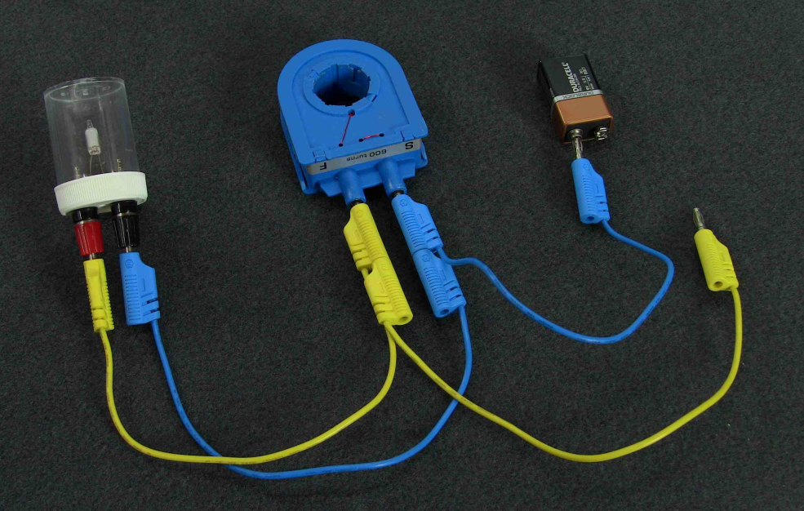

Steps
Step 1: Set up a parallel circuit with IEC ‘Hodson’ 600 turn coil, Neon Bulb (90V), and a battery (only connect up one battery terminal, otherwise you will quickly flatten your battery!).
Step 2: Flick the wire on the battery terminal to make and break the circuit and see what happens? (Note: If you are using a battery holder you can flick the wires from the battery holder with the Jumper Wire from the coil.)
Step 3: See if your friends can explain what is happening!
Step 4: Remember to record your observations. Also try reversing the polarity.

Some Research and Discussion Points
- A 9V battery lit a 90V neon bulb! Impossible! How can 9 Volts become 90 Volts?
- Try the experiment using a 1.5 volt cell (battery).
- Does this violate the conservation of energy law?
- Under what conditions does the Neon Bulb light up?
- Investigate using a switch or a Morse tapper key rather than flicking the wire to make and break the circuit. What implications might this finding have in relation to switches that control devices with large coils?
- Bring the compass near the coil and investigate what is happening.
- Draw a set of circuit diagrams and annotate them to explain what is happening.
- If you have a data logger with a magnetic probe you might use this in your further investigations.
Electromagnetic Cannon

Well at least make a magnet jump and control the motion and position
of the magnet using electricity!

As you will have discovered when you connect up the coil to the battery you can make a pretty strong magnet. Well let’s see if we can make use of this!

Seed Exploration
You will need:
UniServe Induction Tube
Control Rod
IEC ‘Hodson’ 600 turn coil (with banana sockets)
3 x Jumper Wires
Morse Tapper Key
Regulated Power Supply or Battery (1.5 to 9V)

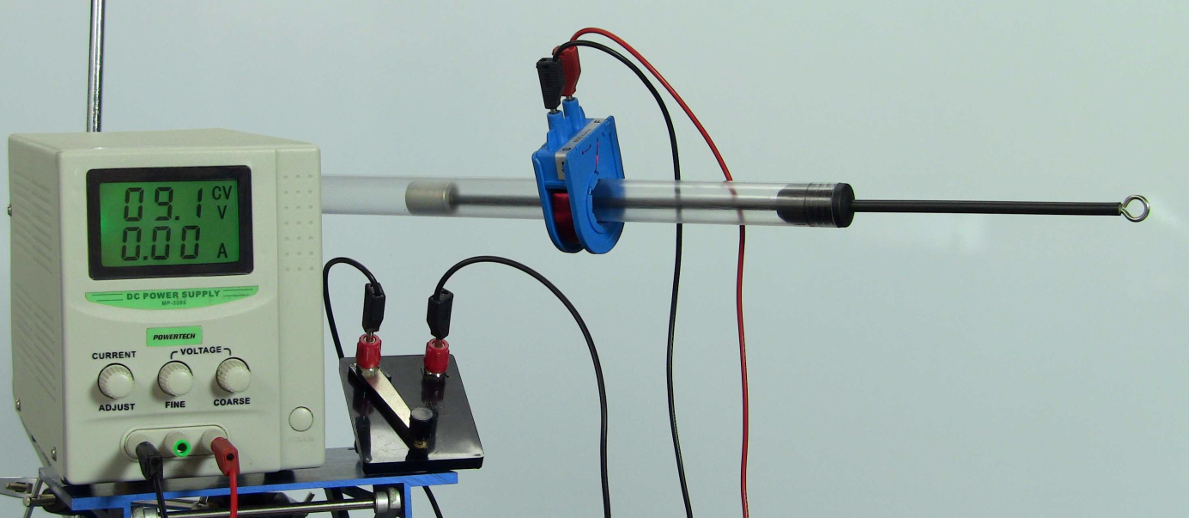

Steps
Step 1: Connect the IEC ‘Hodson’ 600 turn coil, Morse Tapper Key and power supply in series.
Step 2: Slide the IEC ‘Hodson’ 600 turn coil onto the UniServe Induction Tube
Step 3: We leave it to you to explore the physics.
Try energising the IEC ‘Hodson’ 600 turn coil with the UniServe Induction Tube in both horizontal and vertical configurations.
Step 4: Can you position the coil / magnet to make an electromagnetic cannon (well at least make the magnet jump!).
Some Further Explorations and Discussion Points
- What are the underlying physics concepts observed in your explorations?
- How many different ways can you suspend the magnet when the tube is held vertically?
- If you haven’t already tried then see what happens when you reverse the polarity ‘energising’ the coil.
- What difference does rotating or changing the orientation of the coil have?
- What practical applications might such a set up be useful for?

QUANTITATIVE ANALYSIS
(Requiring additional accessories and laboratory equipment as listed and a data logger)

The Long and Short of Coils – Part 1

Now to really carefully investigate the physics of coils!

Seed Exploration
You will need:
UniServe Induction Tube
Control Rod
Long Single Wire (with 2 banana plugs)
Velcro Wire Coil Retainers (or sticky tape)
Data Logger with following sensor – Vernier Instrumentation Amplifier or similar

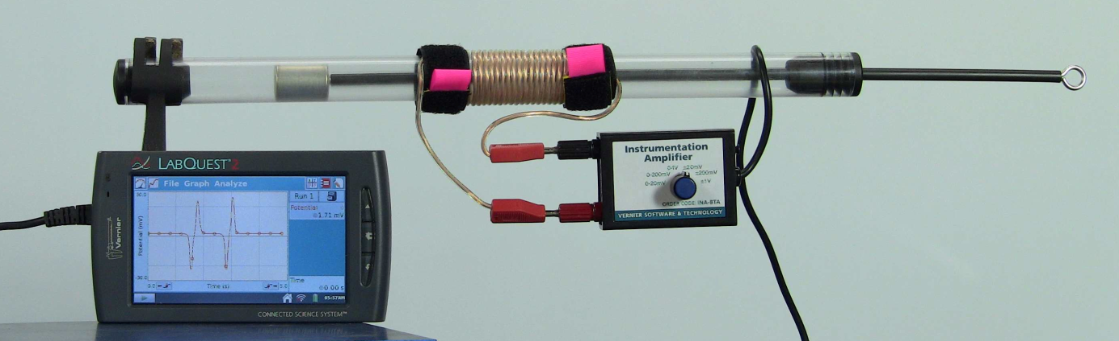

Steps
Step 1: Draw your prediction of what an EMF (voltage) vs Time (seconds) graph will look like for a neatly wound 20 turn coil when a magnet is moved at a constant speed through the coil.
|
+ |
E |
M 0 |----------------------------------------------------------------------------------------> Time
F |
- |
|
Step 2: Using the Long Single Wire (with 2 banana plugs) wind a neat 20 turn coil near the centre of your UniServe Induction Tube. Use Velcro Wire Coil Retainers (or sticky tape) to secure and hold the coil neatly and tightly, so that it does not ‘spring apart’ during your experimentation!
Step 3: Set up your Data Logger and connect the 20 turn coil to the Instrumentation Amplifier (or equivalent sensor).
Step 4: Configure your Data Logger sensor to the most sensitive EMF Voltage setting (for example +/- 20mV)
Step 5: Configure your Data Logger to collect data for 10 seconds.
Step 6: Configure your Data Logger to collect data and display in a graphical format.
Step 7: Insert the Control Rod and position the magnet at one end of the UniServe Induction Tube.
Step 8: Start collecting data and then move the magnet slowly (at a constant speed) through the 20 turn coil.
Step 9: Compare the Data Logger graph to your prediction!
Step 10: Now you are ready to really start planning and exploring the physics of induced EMF in coils!
Refer back to the ‘Coil vs Tube’ investigations – and you can now probably provide some real data to support or destroy your previous theories/explanations you had considered when you did these investigations
Step 11: Time for you to plan and investigate
- 1 turn
- 5 turns
- 20 turns or 30 turns etc
Remember to carefully record the relationships between the directions of motion of the magnet, the speed of the magnet, the position of the magnet relative to the coil and the induced EMF produced. Your Data Logging software may let you annotate the graphs or you can take notes in your laboratory book.

Further Explorations and Questions

- You could slide on the Aluminium Ring (with slit) and use the jumper leads as connectors to measure the EMF induced in the ring as you move the magnet through the ring. (Please Note: aluminium has an oxide coating which is non-conductive, you may need to lightly rub the banana plugs on the ring to remove some of the oxide coating to get a good electrical contact)

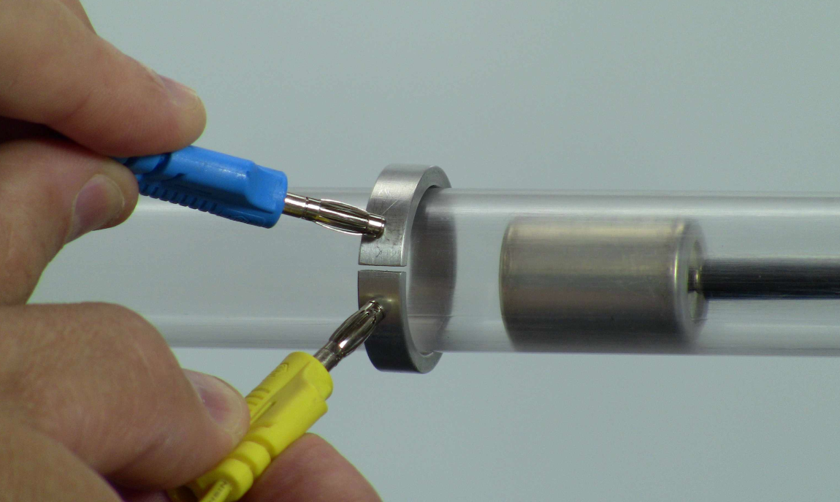

- Is it possible you could also measure the EMF induced in the solid Aluminium Ring (a continuous ring without a slit)? Please explain.
The Long and Short of Coils – Part 2

Now let’s get really serious and try investigations of the ‘not so neat’ wound coils and revisit our old 600 turn friend too.

Seed Exploration
You will need:
UniServe Induction Tube
Control Rod
Long Single Wire (with 2 banana plugs)
Velcro Wire Coil Retainers (or sticky tape)
IEC ‘Hodson’ 600 turn coil (with banana sockets)
Data Logger with following sensor – Vernier Instrumentation Amplifier or similar

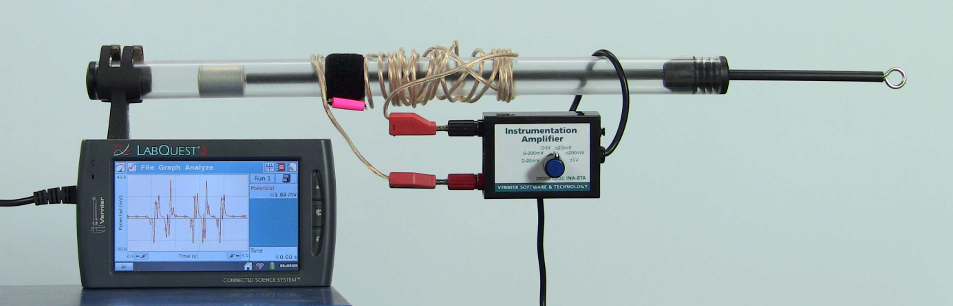

Further Explorations and Questions

- Try winding some not so neat coils and see what happens!
  - Spaces between the windings
  - Windings on top of each other
- Try winding coils clockwise and anti-clockwise
- Try winding the coils with a mixture of both clockwise and anti-clockwise.
- Can you now confidently explain why in the ‘Coil vs Tube - Part 1’ investigation with the 5 cm hand wound coil did not appreciably slow down the magnet the same as the Aluminium Tube? If not then ‘thinking caps’ on!
- Try using the IEC ‘Hodson’ 600 turn coil.
- Can you now confidently explain why in the ‘Coil vs Tube - Part 2’ investigation the IEC ‘Hodson’ 600 turn coil did slow down the magnet a noticeable amount but not as much as the Aluminium Tube?

Troublesome Twins

Seed Exploration
You will need:
UniServe Induction Tube
Control Rod
Long Twin Wire (with 4 banana plugs)
Velcro Wire Coil Retainers (or sticky tape)
Data Logger with following sensor – Vernier Instrumentation Amplifier or similar

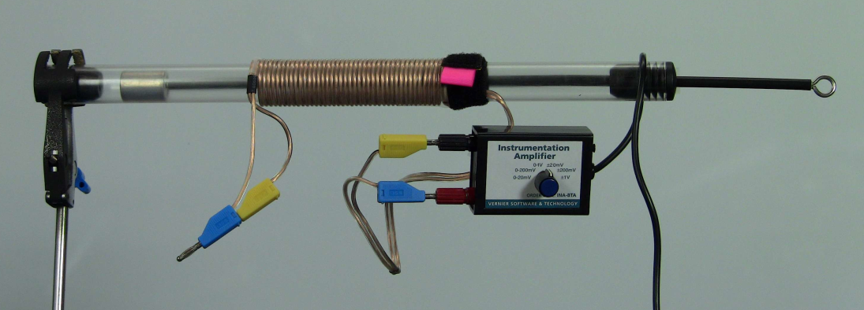

Steps
Step 1: Draw your predictions of what an EMF (voltage) vs Time (seconds) graph will look like for a neatly wound 20 turn Long Twin Wire coil when a magnet is moved at a constant speed through the coil for the following scenarios:
- 1 wire (one wire in the Long Twin Wire)
- 2 wires (when the ends of the Long Twin Wires are connected and the EMF is measured)
- 2 wires (when the ends of the Long Twin Wire are joined and EMF measured at other end) as shown in picture above
|
+ |
E |
M 0 |----------------------------------------------------------------------------------------> Time
F |
- |
|
- Step 2: Neatly wind and secure 20 turns of the Long Twin Wire
Step 3: Connect up Data Logger and Instrumentation Amplifier and test each of your predictions.

Further Explorations and Questions

- Can you explain your observations for each scenario using Lenz’s Law?
- Try winding some not so neat coils and see what happens!
  - Spaces between the windings
  - Windings on top of each other
The Force and EMF vs Displacement Investigations

Now to really get you started investigating some complex phenomena!

You can use Rotational Motion sensors to measure displacement (distance) by rolling the rotational motion pulley on the table surface (usually with mm accuracy). This will now allow you to explore graphically relationships like ‘EMF vs Displacement’ as the magnet moves through a coil. Another interesting investigation would be to graph ‘Force vs Displacement’ for the magnet moving through the Aluminium Tube or an energised IEC ‘Hodson’ 600 turn coil.

So here are some Investigations to get you started.
We will not provide you with detailed Step-by-Step instructions - It is time for you to be real scientific investigators!

Investigation 1 – EMF vs Displacement - for various coil configurations
You will need:
UniServe Induction Tube
Control Rod
Coils:
- IEC ‘Hodson’ 600 turn coil (with banana sockets)
- Long Single Wire (with 2 banana plugs) to wind your own
- Other coils you may have available
Data Logger with following sensors:
- Instrumentation Amplifier
- Rotational Motion Sensor (setup to measure displacement)

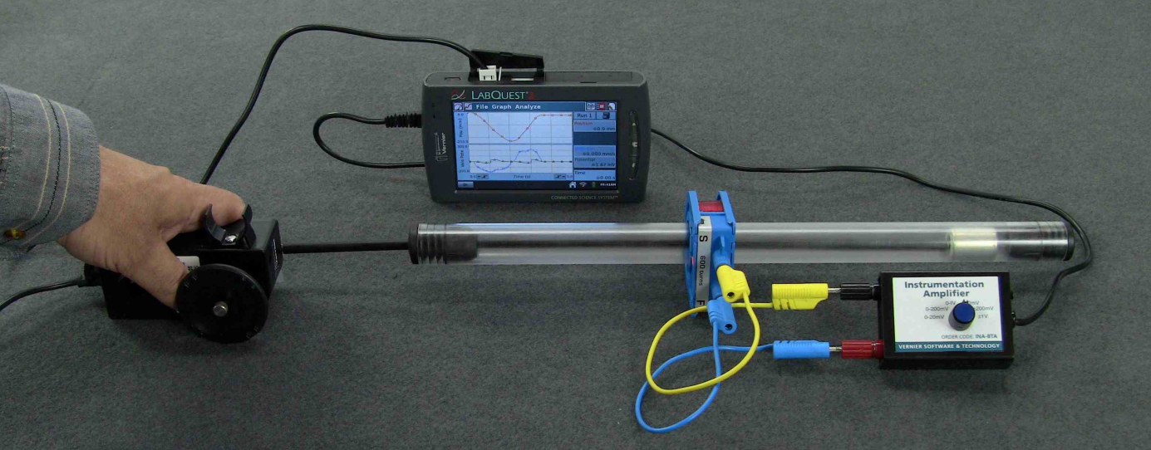

Investigation 2 – Force vs Displacement - for moving a magnet through an Aluminium Tube

You will need:
UniServe Induction Tube
Control Rod
Aluminium Tube
Data Logger with following sensors:
- Force Sensor
- Rotational Motion Sensor (setup to measure displacement)

Set Up Hints: (see the picture below)
- Rotational Motion Sensor (bottom) connected to a Force Sensor (top) using an aluminium rod and the sensor’s thumb screws.
- Force Sensor has been attached to the Control Rod (left) using a short piece of flexible plastic tube.

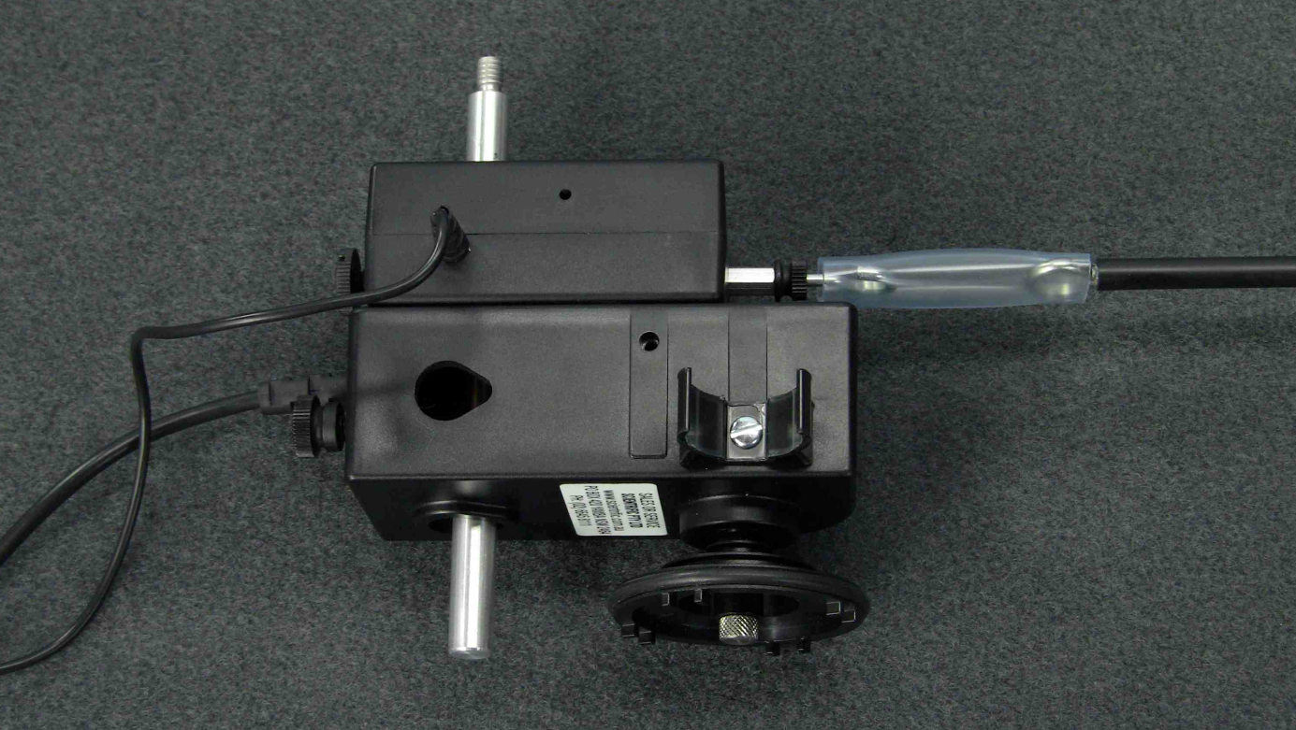

Experimental set up for ‘Force vs Displacement’ when moving the magnet through the Aluminium Tube.

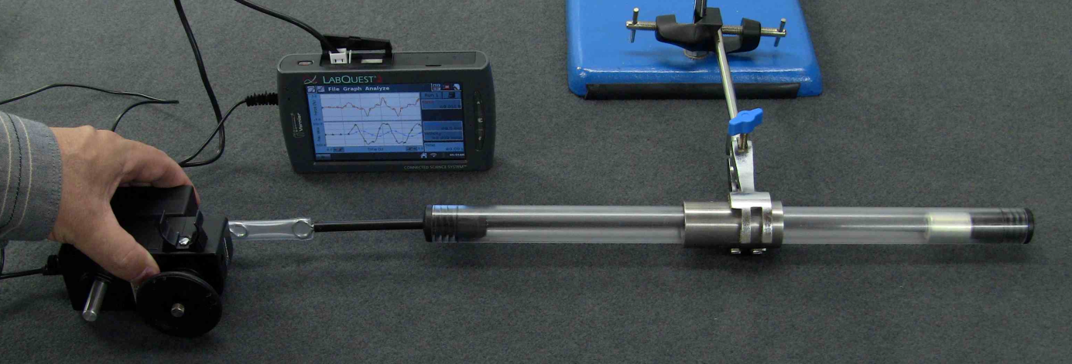

Investigation 3 – Force vs Displacement - for moving magnet through an energised coil.
You will need:
UniServe Induction Tube
Control Rod
IEC ‘Hodson’ 600 turn coil with banana sockets
Regulated DC power supply
Ammeter
Voltmeter
Data Logger with the following sensors:
- Force Sensor
- Rotational Motion Sensor (setup to measure displacement)
- Current Probe

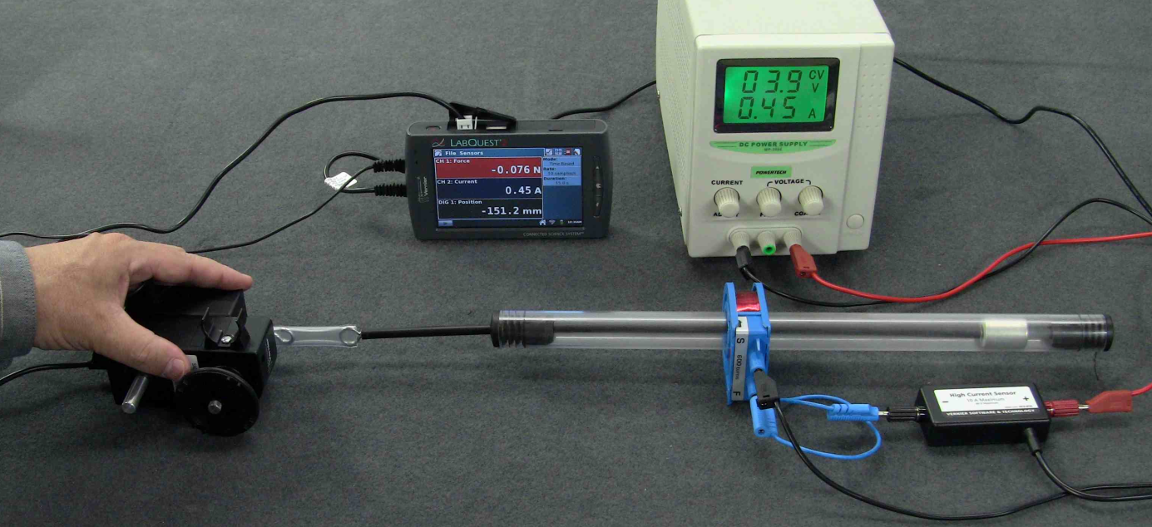

Set Up Hints:
- Securely connect the Rotational Motion Sensor and Force Sensor together.
- Securely connect the Control Rod to the Force Sensor (a short piece of plastic or rubber tube can often be used)

Further Explorations and Questions

- You should be able to use the Rotational Motion Sensor displacement data to also calculate and graph the velocity and acceleration. This will give you further insight into the physics!

Human Endeavour and Application

Following are some historical points and technological applications to launch your research into electricity and magnetism.

Historical Context
- Development of different types of magnets.
- The links between discovery, manufacturing and technologies.

Historical Entities
- Michael Faraday (1791-1867)
- Heinrich Lenz (1804-1865)
- Joseph Henry (1797-1878)
- James Clerk Maxwell (1831-1879)
- Hans Christian Oersted (1777-1851)

Technological Applications
- Magnetic Braking systems
- Magnetic Damping
- Electricity Generation
- Telegraph
- Loud Speaker

The Physics

Following are some physics concepts and to further your research into electricity and magnetism.

Symmetry
- Investigate the concept ‘symmetry’ and relate it back to your investigations.

Magnetism
- Research the various different types of Magnetism:
  - Ferromagnetism
  - Electromagnetism
  - Diamagnetism
  - Paramagnetism

Physical Law’s
- Research:
  - Lenz’s Law and relate it back to your investigations.
  - Faraday’s Law of Induction and relate it back to your investigations.

Terminology
- Induction
- Induced EMF
- Eddy Currents
- EMF
- Back EMF

Interested in Getting Involved!
Interested in Developing and Sharing Ideas and Resources

Please do not hesitate to contact us at uniserve@physics.usyd.edu.au if you would like to share ideas and resources or join our ASELL - Physics Team.

