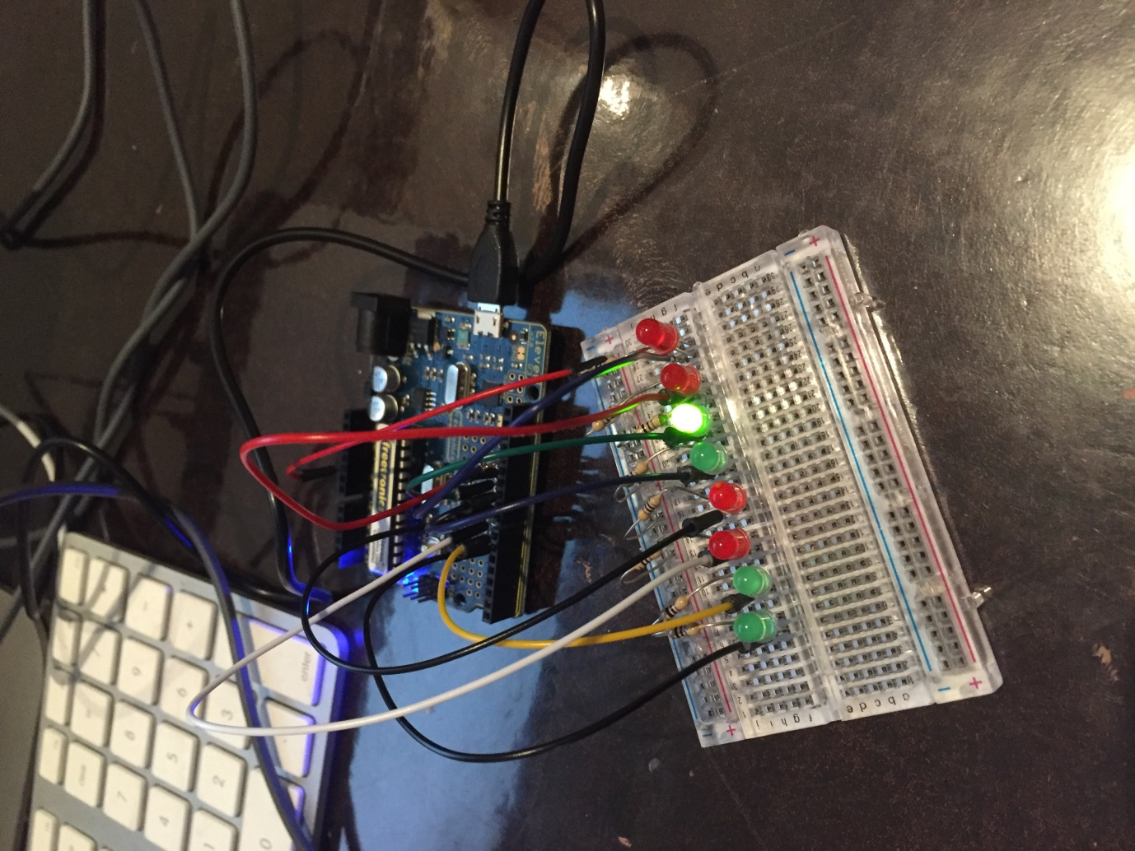

The main thing that troubled me with this project was getting the code to work but I did work it out the end.

\

Project 3

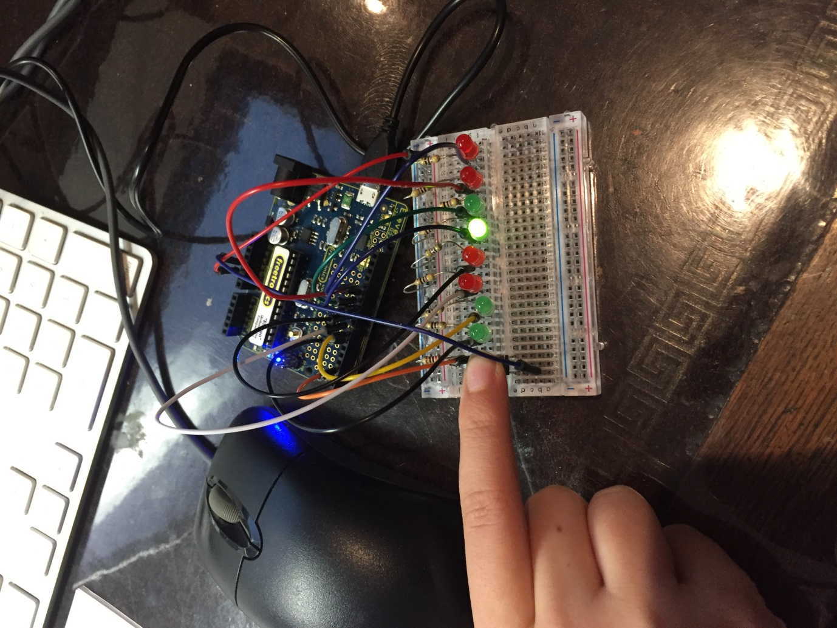

Once again, the code proved to be challenging, but once again I got it working.

Project 5

Ou s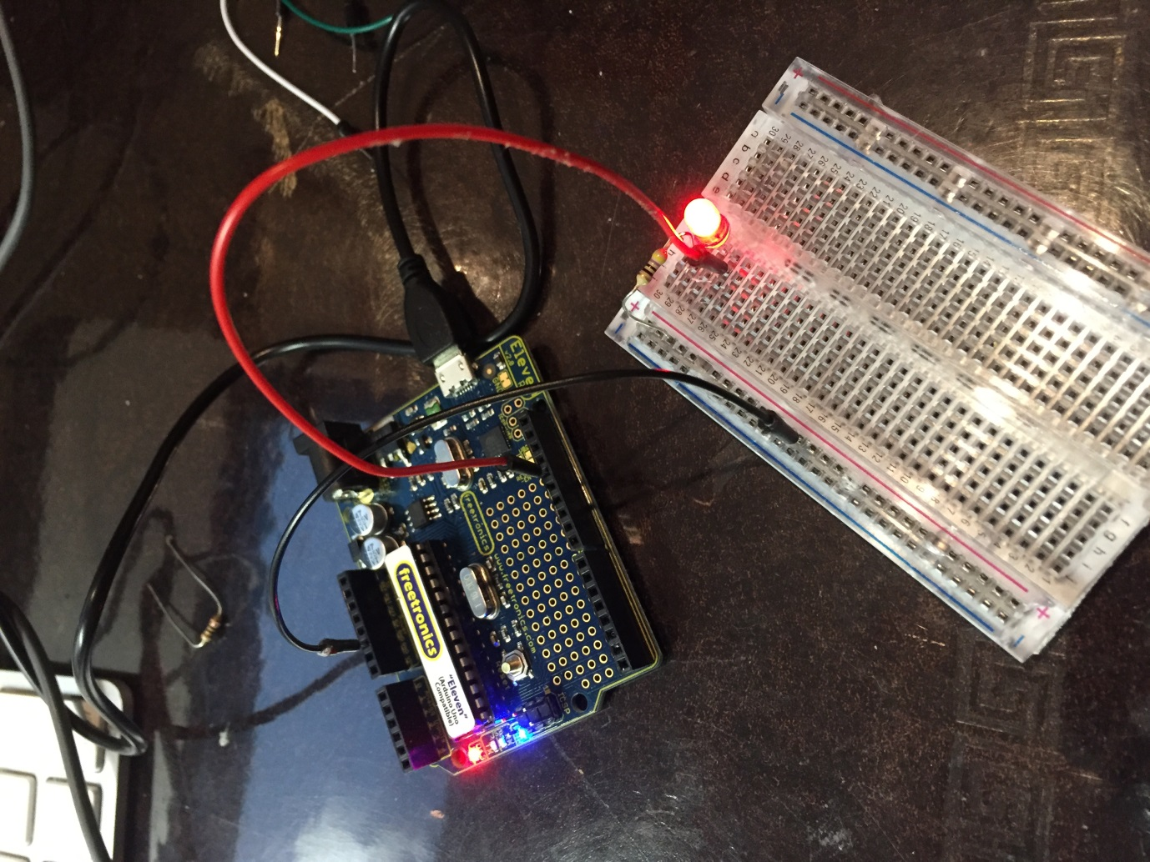

One of the hardest things about this was getting a good picture of the dim light, but if you look at the next one you should see a change. The code was also was difficult.

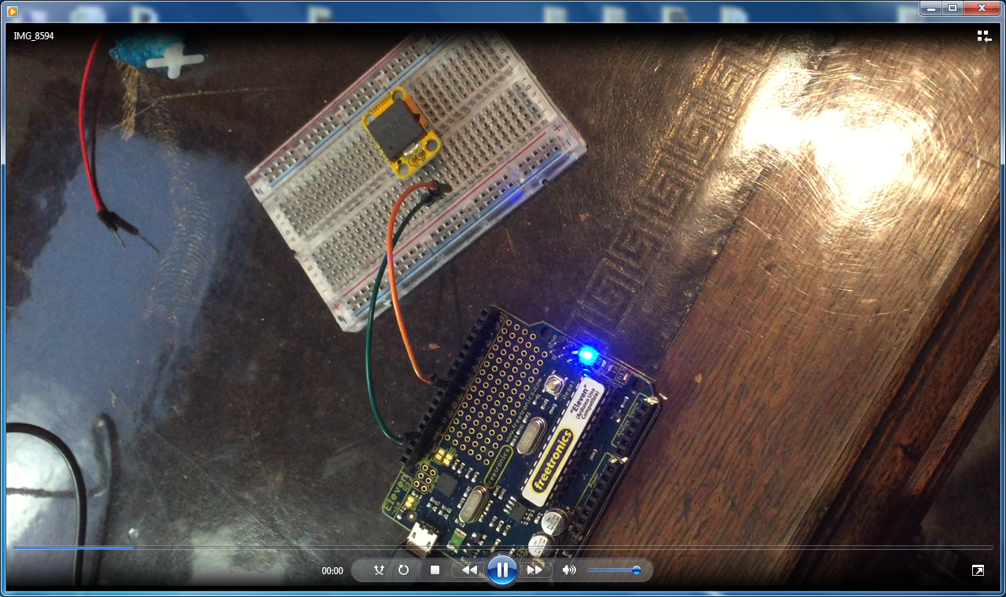

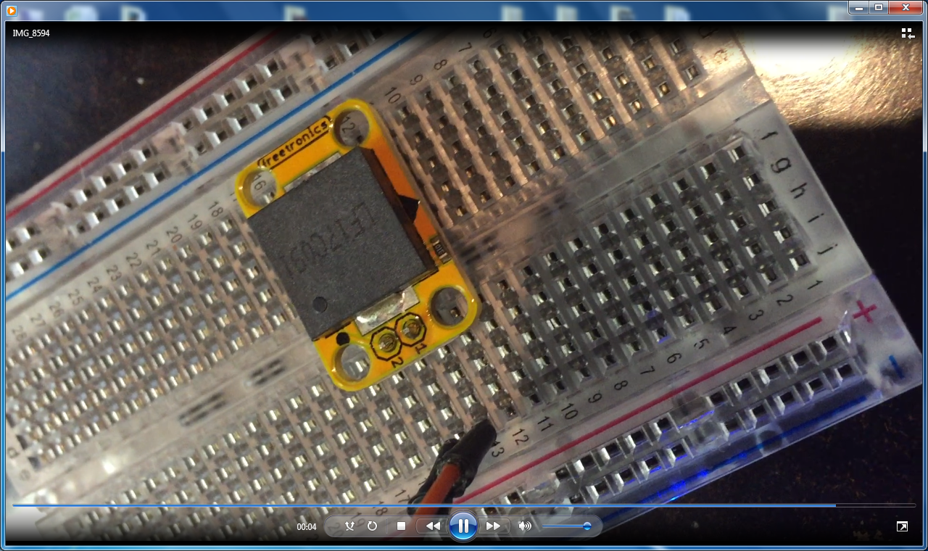

Project 5

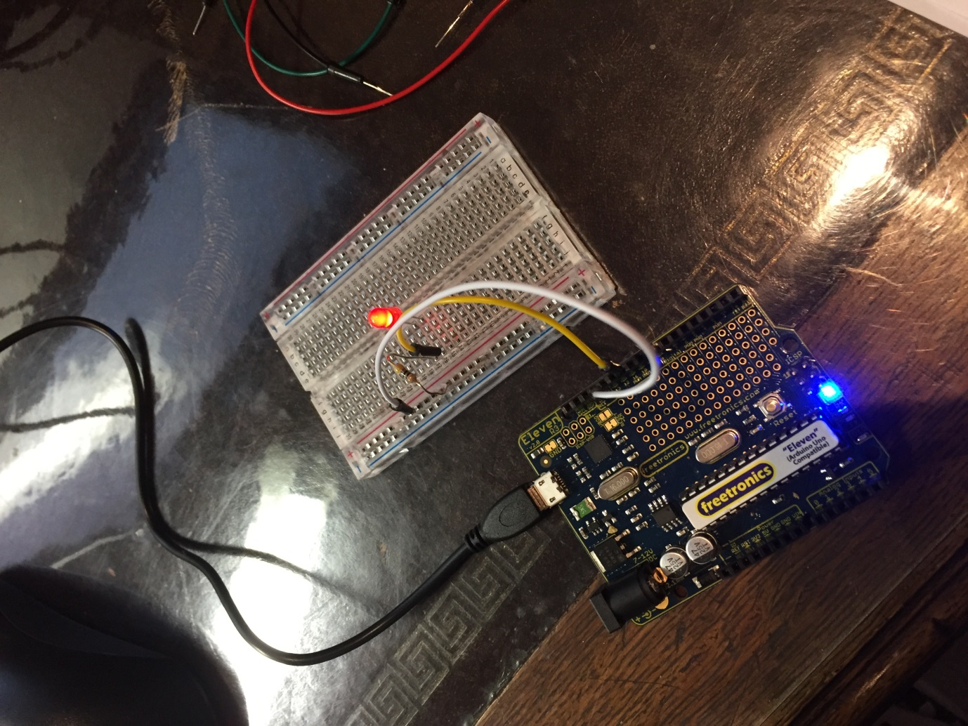

Not much was hard in this one but it turned out to work pretty well. (Look at this and then the previous one to see a light difference).

Project 9

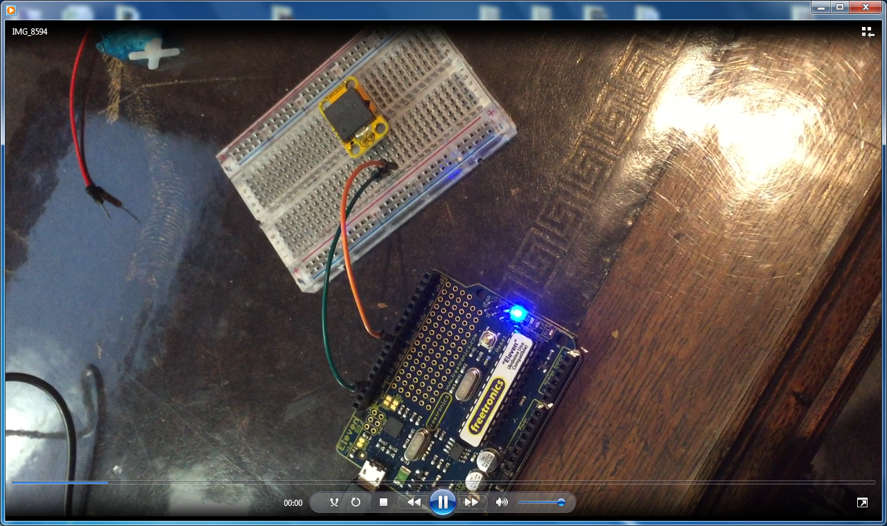

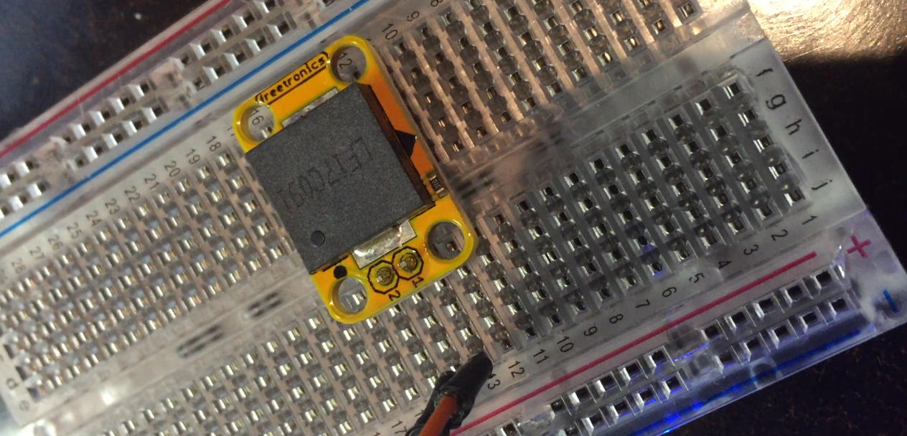

This was great fun (really annoyed dad). Not much troubled me with this except a few small mistakes in the code.